Refinishing Teak Decks

by Wayne Strausbaugh

I recently refinished the teak decks on my Tayana 42. The wood was uneven and grooved after 16 years of cleaning and oiling. The wood and deck seams were sanded flat, decking screws were removed and replaced with shorter ones, and well over a thousand bungs were replaced. No boards were removed. This is a huge job and took over 150 hours of work. If the caulking in the seams has air bubbles in them, it can more than double the time. Think twice about sanding the teak. It can still look good without being sanded. Consider sanding just the raised bungs.

Tayana decks are about 5/8th-inch thick. A major sanding may remove 1/8th-inch of teak from the highest point - the black caulking line. I figure a 35 to 40 year life on my decks until they get too thin. I used a rotary, random-orbit sander to level the decks. The bungs and the seams usually stick up significantly higher than the teak. Almost all the standard 1-inch deck fastener screws were removed and replaced with ¾ inch screws (#8). The original screws were Phillips head and had epoxy on the top and in the screwdriver slots that had to be removed.

The primary consideration once you decide to tackle this job is to get the right tools. In most cases, using what you have on hand will result in a poor job with twice the effort. You will need top quality sandpaper, special taper point drill bits with hole cutters and stop collars, chamfered teak bungs (tapered ends), and lots of wood screws. I’ll just save you weeks of trial and error and 5 hours of research and give you a list. I used Jamestown Distributors so I will list their product codes (2005 Master Catalog):

Product Number | Product | Quantity | Price Per Unit | Total
FUL-20100171 | Taper Point Drill Bit 11/64 in. pg 25 | 2 | $ 4.46 | $ 8.92
FUL-C8 | "Type C Countersink 3/8 in. Cut, 11/64 in. Drill Bit, #8" pg 28 | 2 | $ 5.62 | $ 11.24
FUL-11900375 | Stop Collar 3/8 in. pg 29 | 2 | $ 2.31 | $ 4.62
FUL-K0093 | Hex key, 3/16th in. (for collars & countersinks) pg 28 | 1 | $ 0.08 | $ 0.08
BTL-1252  Page 73 | Life Caulk Teak Deck Sealant 10.5 Oz* | 2 | $ 13.03 | $ 26.06
BTL-1059 | Life Caulk Primer, 8 oz. pg 73 | 1 | $ 13.02 | $ 13.02
For seam caulk- ing, also consider:  TDS-SIS440B10C | Teak Decking Systems Oxime  rubber-silicone mix (info at  www.teakdecking.com/ ) | 2 | $ 12.09
BUNG38T  Page 160 | Teak Bung 3/8 in. X 100 (chamfered) | 3 | $ 8.15 | $ 24.45
NBC-250 | Professional Caulking Gun pg 74 | 1 | $ 23.72 | $ 23.72
3M-06817 | Blue Long-masking Masking Tape 3/4 in. | 2 | $ 3.22 | $ 5.62
3M-06818 | Blue Long-masking Tape 1 in. | 3 | $ 4.32 | $ 12.96
FSSWSFP8X34 | Wood Screw Flat Head Phillips S/S 8 X 3/4 in. Page125 | 200 | $ 4.73 | $ 9.46
3M-86488 | 3M 236U Gold Rolls – 5” Stikit  80-grit sandpaper pg 95 | 1 | $ 30.24 | $ 30.24
Or 3M-86468 | 3M 236U Gold Rolls – 6” Stikit  80-grit pg 95 | 1 | $ 42.63 | $ 42.63
3M-86492 | 3M 236U Gold Rolls – 5” Stikit  180-grit pg 95 | 1 | $ 27.90 | $ 27.90
Or 3M-86471 | 3M 236U Gold Rolls – 6” Stikit  150-grit pg 95 | 1 | $ 39.35 | $ 39.35
Grand Total (with 5” sandpaper – will do 200 bungs) |  |  |  | $ 198.29
(with 6” sandpaper – will do 200 bungs) |  |  |  | $ 222.13
Top of Form

Also Hex
I have no affiliation with Jamestown Distributors. But I use them a lot! Phone: (800)
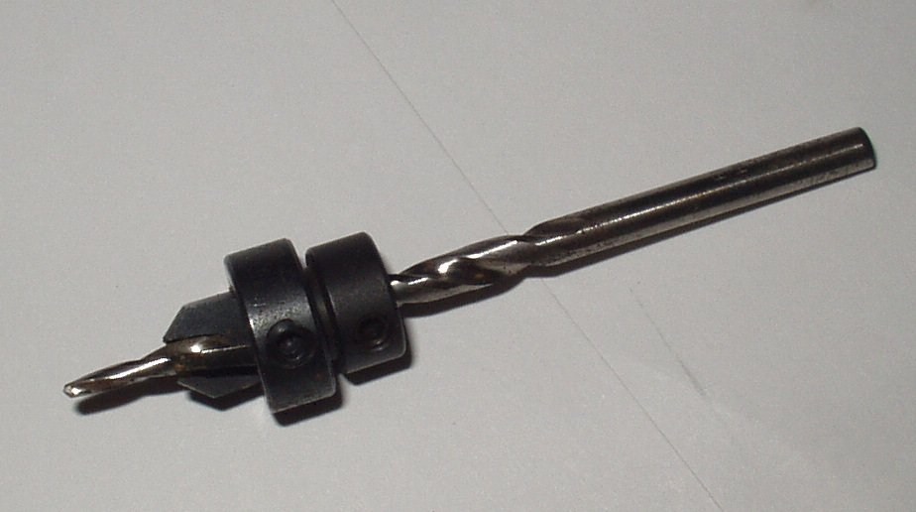
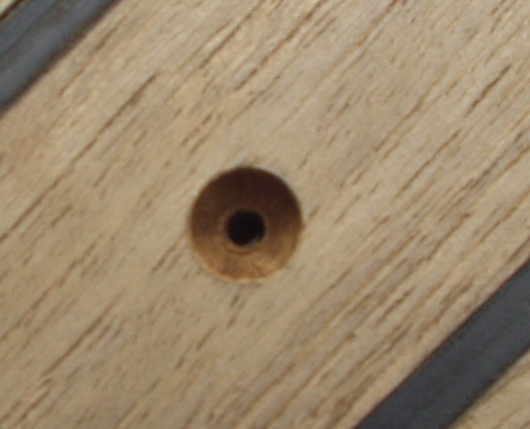

423-0030, online www.jamestowndistributors.com

Proper bung hole Taper point drill & countersink Bungs – buy in bulk to select
matching colors

The job was started with a belt sander to speed up sanding where the wood was unusually rough. Most of the initial sanding was to the deck seams. They tend to stand taller than the teak. The majority of the sanding was done with a random orbit, rotary sander. Don’t look to achieve your final sanding depth initially. Do about 80% to expose screw heads and loose bungs. Save a bit for final sanding of the new bungs and epoxy residue. If a bung appears thin, it is best to pull it. I had lots that looked good, only to show as too thin a year later. If you see any movement of the bung at all, it is best removed.
Screws, hole cutters and bungs came from Jamestown Distributors. You have to have a professional-grade, taper-point drill bit and counter sink to redrill each hole. Jamestown has them with adjustable stop collars so you can individually set the depth of the screw and bung hole. The counter sinks last through about 500 holes before they dull out. Teak is a tough wood! I believe you would be wasting your time to try a Stanley countersink or something from Lowes or Walmart. They tend to leave a rough edge on the hole and don’t last. You'll spend $200 just on drill bits, countersinks, screws, and caulking compound for about a third of the deck. Don't forget the blue tape - you'll need to cover the holes at the end of the day if you don't get a screw and bung back in.

Voids in the deck seam compound were the biggest problem. Your boat may or may not have these voids. First, do a general evaluation of your deck seams. Does the sealant adhere nicely to the teak boards on either side? Do the teak deck boards feel the slightest bit loose when all the screws are removed? If you can just patch the seams vice replace them, look for air bubbles in the caulking. You may not find them prior to beginning the deep sanding. I found hundreds of air bubbles (hollows) in the seam compound. But the caulking was in such good shape and adhered so tenaciously to the teak that I elected not to do a complete reseaming. It took almost as long to tape/recaulk/sand the repaired deck seams as the sanding, drilling, and rebunging of the rest of the deck. Use a razor knife to cut out the void, cutting at an angle of about 45 degrees. You can’t caulk a hole with a 90-degree angle (vertical walls). Tape the teak around the hole with 1-inch wide blue tape, prime (Life Caulk primer requires an hour wait before applying caulking. No primer - no stick), caulk by pushing the tip of the caulking gun away from you, and then level the caulking with an old credit card or a flexible putty knife. After the caulking sets up (and within 24 hours), apply a second coat since the original will leave a dip or “valley” in the sealant. A third coat may be required to achieve a level seam. If you are doing a complete recaulking of deck seams, just one coat will do since the “valleys” in the sealant would be uniform. I probably had 700 individual caulking repairs. Complete recaulking was only required on about 5 linear feet of deck seams. Otherwise, all the repairs were patches of 1 to 2 inches in length. I learned early on that if the original deck caulking is adhering well, leave it alone!

I only have experience with Lifecaulk Teak Deck Sealant. Many are now using Teak Decking Systems (TDS) Oxime rubber-silicone mix. The Teak Decking Systems sealant doesn’t appear to use a primer and is a thixotropic material that does not sag during cure. This makes it better for small repairs of deck seams since one coat may suffice. It is widely lauded for complete seam replacement as well. It is a one-part sealant and comes in a standard 10.3 oz. cartridge. Harvey Karten of the Tayana 37, Night Heron, in San Diego, has used TDS and provided the below procedures:

Complete Deck Seam Recaulking by Harvey Karten

Once again, it is the tools that are important for a fast, quality job. For seam removal and sanding, consider buying the Fein Multimaster Variable Speed Tool, Part #FPT-MSXE-636-2, $225 at www.jamestowndistributors.com/product;part;5389;process;search;ID;,Tools,Power.Tools,Fein.Power.Tools,Fein.Multimaster,Fein.Multimaster.MSXE . For seam removal, buy the teak blades that come in 3 mm, 4 mm, and 5 mm widths. Jamestown has the 3 mm blades. The others may require special order. Measure your seams to determine which one to buy. Blades are $53 each but people that have used them swear by them.
Get lots of acetone to wash the TDS off your body parts. Use rubber gloves to minimize change of skin texture and avoid that funny taste from absorbing acetone.
For a Tayana 37, about 15 tubes of TDS should be about right for caulking the decks. The cockpit will take another 4-6 tubes. Much depends upon the width and depth of the seams. It will take at least 5 rolls of 1-inch wide, 3M Blue tape for the decks.

1) Clean out the old caulking with a Fein Multimaster. Then, using the flat grouting blade (medium grit) on the Fein, sand down the side walls of the seam and deepen the groove where it is needed (this blade is included with the Fein). This gets rid of any last bits of the old caulking and exposes fresh wood. It goes very quickly with the Fein. I had previously been doing this with a bent, sharpened screwdriver and found it a slow and laborious process. I also missed a lot of spots with old caulking. Although only time will show if this is valid, I think that the Fein grouting blade may have been the most important tool I used in this whole clean n' ream operation. I would then wash liberally with acetone.
2) Tape each side of the seam carefully with 3M blue tape..
3) I then used a squeeze bottle filled with Smith's CPES (clear penetrating epoxy solution), liberally poured it into the seams and flooded the side walls of the seam. This only takes about half an hour to do all the seams on the boat using the squeeze bottle with a long "straw"-like spout with a narrow tip. On a Tayana 37, it only required a total of about 1 ½ pints of CPES for all the decking.
4) Now, caulk with the TDS, forcing material into the seam and expelling any air bubbles. Squeeze in an excess of material, then within a minute or two, force it in with a small wooden spatula, leaving a slight hump.
5) IMMEDIATELY after you smooth it with the spatula, remove that piece of tape (within 2 to 4 minutes). I initially waited too long and the TDS immediately starts to form a skin. At that point, when you lift the tape, it also pulls up the surface skin of caulking, causing a slight hollow in the seam and a curlicue wave above it. Once I learned the trick of removing the tape immediately, it went well. I also found that if I let it cure almost completely overnight and removed the tape very carefully the next day, it worked out OK. But it took a lot longer and the tape often tore at the seam, requiring teasing it out with tweezers.
5) Curing typically starts within several minutes and you can walk on it the next day. Curing can be speeded up by sprinkling on a little water. Wait a few days and then trim the excess using a single edged razor blade. The TDS can then be lightly sanded and left a bit 'proud' to provide better footing on the deck. It did not shrink or sink into the seams, but actually protruded slightly.
I had planned to put in a breaker strip in the bottom as per the instructions, but the seams were so uneven in width, that I finally gave up on trying to do that. I asked the people at TDS about this and they sort of hedged their response. I was left with the impression that while it might be helpful, it wasn't all that essential. The reason seems to be that TDS has really high adhesion, combined with a sustained 20-40% elasticity over a 20 year period (estimated). Most other caulking compounds lose their elasticity rapidly and that results in breaking the bond to the side walls of the seam.

After you open a tube of TDS, you can cover the tip with Saran wrap, and it will still be good for weeks (to months?). It initially has a low viscosity, so it flows into the seams very easily. The only drawback to TDS is that it is a mess when it gets on your hands and hair.
Adding additional caulking is supposed to be easy. Rough the surface with a bit of 80-grit sandpaper, rinse with acetone, and put in the caulking. They say that the two streams will tightly bond immediately. This also makes repairs easier.

Some more hints on refinishing teak decks - the right tools and materials!

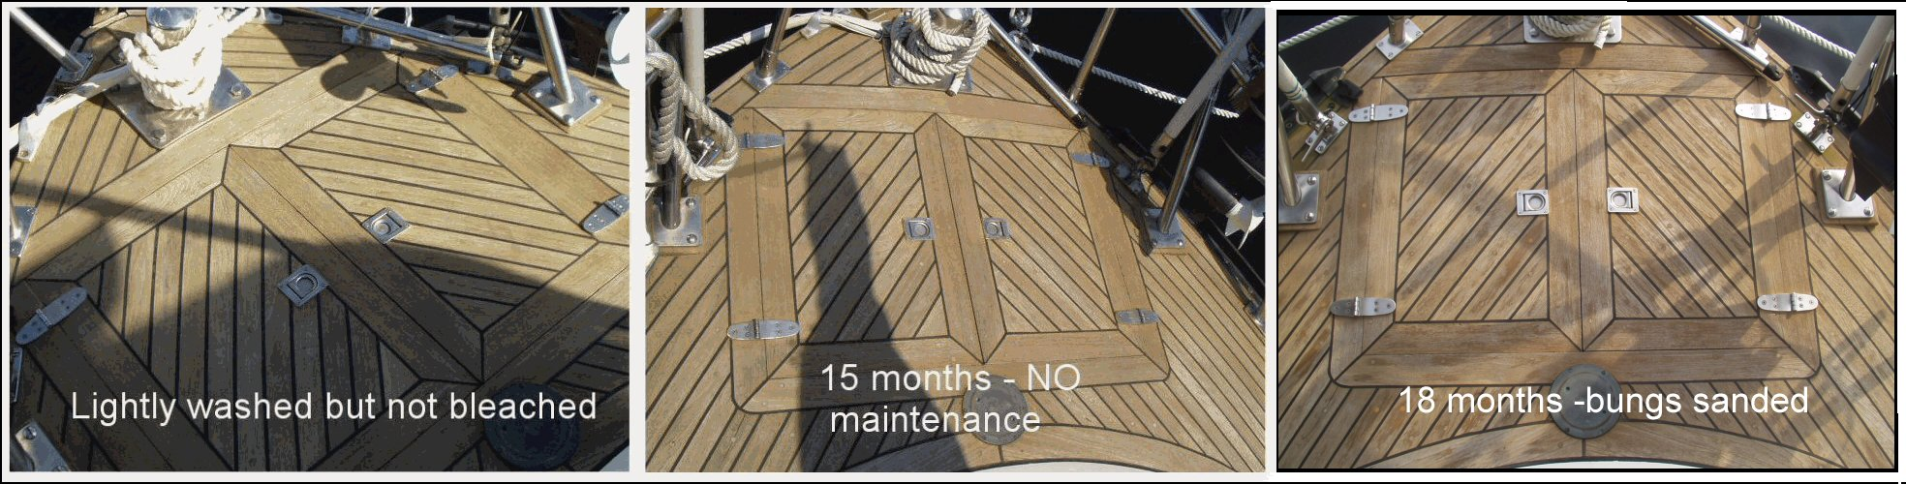
- Sand the decks with 80-grit first. Use the 150 to 180-grit as you finish sanding and caulking. The decks can then be left to weather back to silver-gray or they can be oiled. See my Teak Oil Test document at http://tognews.com/ftpfiles/Decks_Teak_Oil_Test/ on the FTP site for a long-lasting oil treatment.

Teak oil test using 1/3rd each Teak Wonder, Semco Clear, & Olympic deck stain (caramel)

- To pull a bung, try a good sharp awl and a small hammer. I also found a dental pick came in handy for the small work. You must meticulously remove all debris from a screw head so the hole is once again perfectly round. If it is not, the screw will crack and raise the deck around the hole as it comes up. Razor blade tools don’t work here. You need to put in the same size 3/8th-inch teak bung so you have to ensure that the hole is not damaged when pulling the original bung. Start in the middle and work outwards. Underneath the bung, the head of the Phillips-head screw will most likely be filled with epoxy. An awl and hammer works well here too. Punch right into the middle of the screw slot with a hammer and then "flip" the tip of the awl out towards the four corners to remove the epoxy.

- Use an electric drill or screwdriver. This is a must! I removed 1000 to 2000 screws this way without finding one that I couldn't pull. It is too easy to strip the head of a screw with a hand screwdriver.

- Redrill the hole for the new screw using the countersink and drill bit (Hint: put both countersinks on the bit. A single countersink tends to slip up the shaft of the bit). Hand drilling works fine. The old hole will line you up. Drill ¾ of the way down, then vacuum the hole and bit and finally drill to final depth. You get a cleaner cut with the debris removed. Teak will continually clog the countersink. Clean it prior to drilling. Vacuum the hole prior to replacing the screw.

- Put a little Life Caulk on each screw to seal the screw hole. Just enough to have it protrude around the screw head when the screw is tightened. I don’t think epoxy is a proper sealant here. And you will need to be able to remove this screw in the future if the bung pops off. An electric screwdriver with an adjustable torque setting is a necessity. When replacing screws, you can split the wood if you put the new screws in too tight. Just snug works fine. The torque setting ensures that you don't over-do it. Try setting 2 or 3 (on a scale of 10).

- Coat the bung with epoxy and install it before the caulking gets sets up. When it dries, cut the bung short with a chisel (tap it with a hammer). Cover the bung with a wet sponge when you cut it and you won’t lose all the bung heads overboard. Sand the bung flush as you achieve final depth with your deck-sanding job or use 80-grit sandpaper and a sanding block to sand each bung individually. Some people use varnish to seal the bungs.

On an older boat, you are going to find at least one area where there is a little water under the teak deck. The telltale sign is a black spot around a bung as the water wicks up and discolors the area. Or when a screw is backed out, look for water to perk up through the hole as it sits in the hot sun. Don’t panic when you spot water. The boat won’t sink! If the decks are not soft when walked on, they are best left alone after sealing the route of water intrusion. The water can be easily vacuumed out with a wet/dry vacuum. Use the sun to heat up the deck, expanding the boards and forcing water out the bung holes. It can take a considerable amount of time. Putting a sheet of plastic over the deck and taping the edges tightly can dry an entire area. Cut a hole for the vacuum hose and tape it in place. This will also suck water out of loose seams as well as bung holes. Tape over the holes with blue 3M tape at night.

If you have ever considered removing your teak decks entirely, it may be worthwhile to buy the above tools (you will still need them to maintain the cockpit teak) and try refinishing a section of your deck. Anyone can achieve excellent results if you have the knowledge and the tools. The results can be very satisfying.

While this article concentrates on the tools needed to refinish your teak decks, an even more comprehensive article by Sue Canfield is available on the Tayana Owners Group FTP site. It also contains step-by-step pictures:

http://tognews.com/ftpfiles/Decks_TeakTherapy_SueCanfield/

